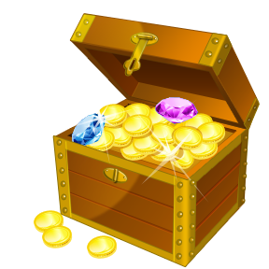
“Thesis” Treasure Hunt…..
Directions: Follow the steps below today to find your very own thesis.

Be on the lookout today for an opinion. Record it in the box below.

Great! Now that you have your opinion find one fact that backs it up.

Getting closer! Come up with another fact to support your idea.

Almost there. You need one more fact. Record it below.

Now, find your thesis. Add your opinion to your three facts in the space below.

