Teens &
Video Games
Pong, created by Atari, came out 38 years ago and was the first commercially successful video game. (NPR)

78% of teens ages 12-17 have a cell phone; almost half (47%) own smartphones. (PEW)

“Excessive media use has been associated with obesity, lack of sleep, school problems, aggression, and other behavior issues.” (AAP)

“Children and adolescents can become overly involved and even obsessed with videogames. Spending large amounts of time playing these games can create problems and lead to:
- poor social skills
- time away from family time, school-work, and other hobbies
- lower grades and reading less
- exercising less, and becoming overweight
- aggressive thoughts and behaviors” (AACAP)

“Playing the video games actually had a very slight calming effect on youths with attention deficit symptoms — and helped to reduce aggressive and bullying behavior.” (PsychCentral)

“Teenage boys age 13-15 who play violent video games are more likely to be aggressive nad have higher anxiety levels in their daily lives.” (US News)

“Social media not only can help children and teens learn facts, but it can also help teach empathy, racial and ethnic tolerance, and a whole range of interpersonal skills.” (AAP)

“A study of nearly 500 12-year-olds found that the more kids played video games, the more creative they were in tasks such as drawing pictures and writing stories. In contrast, use of cell phones, the Internet and computers (other than for video games) was unrelated to creativity, the study found.” (MSU)
Video games are really fun and exciting to play.

“Playing [violent video games] can and does stir hostile urges and mildly aggressive behavior in the short term. Moreover, youngsters who develop a gaming habit can become slightly more aggressive — as measured by clashes with peers, for instance — at least over a period of a year or two. Yet it is not at all clear whether, over longer periods, such a habit increases the likelihood that a person will commit a violent crime.” (NY Times)
Teens, Sports & Exercise

“If all adolescents played on at least two sports teams per year — in other words, one team per season — obesity rates would plunge 26 percent and the prevalence of overweight adolescents would fall by 11 percent.” (NYTimes)

“Physical education classes...did not reduce or prevent weight gain, likely because they do not offer students the same level of regular, challenging exercise as competitive sports.” (NYTimes)
A recent study published in the “BMJ journal Archives of Disease in Childhood, suggests that 14 hours of physical activity a week is best for promoting good health in teenagers. However, they found that more than 14 hours appears to be detrimental to their health.” (Medical News Today)

“Nearly half of teens ages 12-21 years are not vigorously active on a regular basis.” (Palo Alto Medical Foundation
“Overweight teens are more likely to be overweight adults, which makes them more likely to develop heart disease and high blood pressure.” (Palo Alto Medical Foundation)

“Today, about one in three American kids and teens is overweight or obese, nearly triple the rate in 1963.” (American Heart Association)
“Only one in three children is physically active every day.” (President's Council on Fitness, Sports & Nutrition)
“Children now spend more than seven and a half hours a day in front of a screen (e.g., TV, videogames, computer).” (President's Council on Fitness, Sports & Nutrition)

“Among people 19 and younger, 250,000 were treated in emergency rooms for concussions and other sports- or recreation-related brain injuries in 2009, up from 150,000 in 2001.” (National Academies)

“Regular physical activity—
- May help improve students’ academic performance, including
  - Academic achievement and grades
  - Academic behavior, such as time on task
  - Factors that influence academic achievement, such as concentration and attentiveness in the classroom.” (CDC)

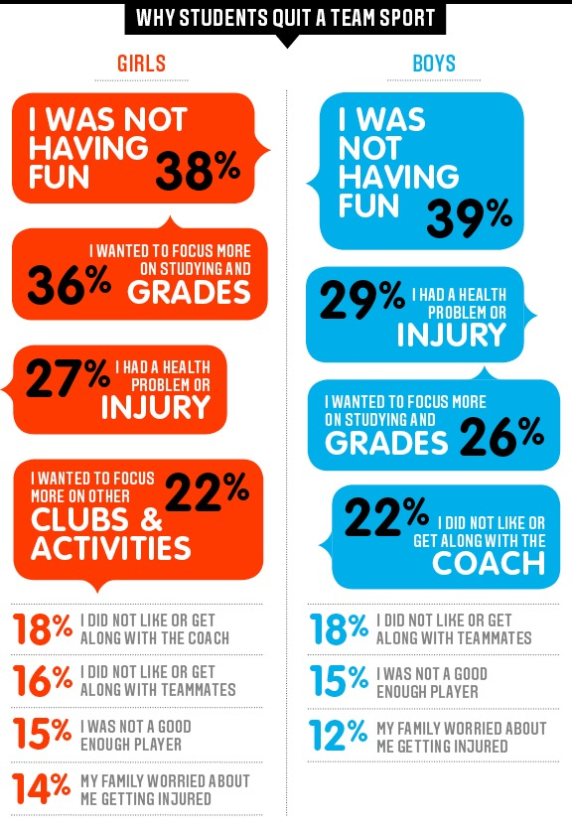(ESPN)

Milk
"Milk is one-stop shopping for nutrition. It contains nearly all the basic nutrients that a growing child needs: fats, carbohydrates, proteins, vitamins and minerals (except iron).” (ProCon.org)

“Dairy products contribute to a surprising number of health problems. They can impair a child's ability to absorb iron and in very small children can even cause subtle blood loss from the digestive tract.” (ProCon.org)

“Findings from ongoing studies indicate that four to five servings/day of calcium-rich foods such as milk and other dairy products are needed to optimize peak bone mass during adolescence.” (ProCon.org)

“Several studies of teenagers have found that their adult bone health is related to their physical activity level earlier in life, but not to the amount of milk or calcium they consumed. Milk consumption is apparently no help later in life either.” (ProCon.org)

“Mounting research indicates that consuming more calcium in the diet - particularly from calcium-rich dairy foods - can speed up weight loss and reduce body fat, particularly abdominal fat. Consuming dairy products appears to help prevent body weight and fat gain in children and adults, Caucasians and African-Americans, males and females.” (ProCon.org)

"It is well known that rBGH [synthetic bovine growth hormone] increases levels of another growth hormone, IGF-1, which is identical in cows and humans. At elevated levels, IGF-1 is known to increase cancer rates in humans.” (ProCon.org)

“In 2003, over 51% of North Americans with non-European ancestry were lactose intolerant. For East Asians the level of lactose intolerance was 90-100%.” (ProCon.org)

“Milk accounted for about $27 billion in sales for dairy farmers in 2005, making milk the second largest agricultural commodity industry in the United States.” (ProCon.org)

“The National School Lunch Act (397 KB) requires that schools serve milk as part of the federally subsidized National School Lunch Program.” (ProCon.org)

“According to the California Farm Bureau Federation, it takes 48.3 gallons of water to produce one eight ounce glass of milk. This water usage includes not just the water that the cow drinks but also the water it takes to grow the cow's food and the water it takes to process the milk.” (ProCon.org)

“One taco has more calcium than one cup of low fat milk, according to a 2005 United States Department of Agriculture report, although milk has twice the calcium of a cheeseburger.” (ProCon.org)
Self-Esteem

“Low self-esteem is a thinking disorder in which an individual views him/herself as inadequate, unworthy, unlovable, and/or incompetent. Once formed, this negative view of self permeates every thought, producing faulty assumptions and ongoing self-defeating behavior.” (Self-Esteem Institute)

“Among high school students, 44 percent of girls and 15 percent of guys are attempting to lose weight.” (PBS)

“Over 70 percent of girls age 15 to 17 avoid normal daily activities, such as attending school, when they feel bad about their looks.” (Dove)

“More than 40 percent of boys in middle school and high school regularly exercise with the goal of increasing muscle mass.” (New York Times)

“75 percent of girls with low self-esteem reported engaging in negative activities like cutting, bullying, smoking, drinking, or disordered eating. This compares to 25 percent of girls with high self-esteem.” (Dove)

“About 20 percent of teens will experience depression before they reach adulthood.” (TeenDepression.org)

“Teen girls that have a negative view of themselves are four times more likely to take part in activities with boys that they’ve ended up regretting later.” (DoSomething.org)

“The top wish among all teen girls is for their parents to communicate better with them. This includes frequent and more open conversations.” (Dove)

“38 percent of boys in middle school and high school reported using protein supplements and nearly 6 percent admitted to experimenting with steroids.” (New York Times)

“7 in 10 girls believe that they are not good enough or don’t measure up in some way, including their looks, performance in school and relationships with friends and family members.” (Dove)

“A girl’s self-esteem is more strongly related to how she views her own body shape and body weight, than how much she actually weighs.” (Dove)

Teens & Sleep

“Teens need about 9 1/4 hours of sleep each night to function best (for some, 8 1/2 hours is enough). Most teens do not get enough sleep — one study found that only 15% reported sleeping 8 1/2 hours on school nights.” (“Teens and Sleep,” National Sleep Foundation)

“Not getting enough sleep or having sleep difficulties can limit your ability to learn, listen, concentrate and solve problems.” (“Teens and Sleep,” National Sleep Foundation)

“Any delay in the start of school will most likely result in a later release time, which may reduce time available for practice and matches (especially daylight hours). One result of later release times may be greater competition for field and gym space, which may result in the cancellation of some programs (JV and sports like swimming and golf, for example, which often require the use of facilities during off-peak hours).” (“Eight Major Obstacles,” National Sleep Foundation)

“Teens tend to have irregular sleep patterns across the week — they typically stay up late and sleep in late on the weekends, which can affect their biological clocks and hurt the quality of their sleep.” (“Teens and Sleep,” National Sleep Foundation)

“Biological sleep patterns shift toward later times for both sleeping and waking during adolescence -- meaning it is natural to not be able to fall asleep before 11:00 pm.” (“Teens and Sleep,” National Sleep Foundation)
Later start times mean later school release times. “A delay in release time for students means that students with after-school jobs may be affected. This issue is important for certain students and their families who rely on the extra income to get by. Therefore, [a change in school start times] may disproportionately affect low income families.” (“Eight Major Obstacles,” National Sleep Foundation)

“A recent poll conducted by the National Sleep Foundation found that 60% of children under the age of 18 complained of being tired during the day, according to their parents, and 15% said they fell asleep at school during the year. (“School Start Time and Sleep,” National Sleep Foundation)

In a 3 year study, urban teachers noticed little to no impact on student behavior with later school start times. “Urban schools reported fewer students being involved in extracurricular activities, as well as conflicts with after-school jobs and compromised earnings.” (“Backgrounder: Later School Start Times,” National Sleep Foundation)

“Going without enough sleep can make a teen more likely to get sick. Why? Because the number of T-cells in the body--cells which help us stay healthy--falls by 30 to 40 percent.” (Washington Post Answer Sheet)

“Sleep-deprived teens get more headaches than those that don’t.” (Washington Post Answer Sheet)

“Students who earn C’s and below go to sleep later and have less regular sleep patterns than students who get better grades. Sleep affects learning and memory.” (Washington Post Answer Sheet)

“A change in schedule for high school students will usually result in a change for younger students. If elementary students have the earliest start times, they may be waiting for the bus in the dark early mornings, or waiting at home alone after school.” (“Eight Major Obstacles,” National Sleep Foundation)

