Map It:
Thesis Statements

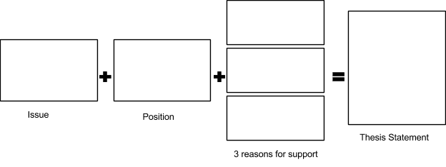

Summer is the best season of the year because there is no school, it is warm enough to swim and play outside, and there is plenty of time to hang out with friends.

Volunteering is important in middle and high school because service gives students a sense of purpose, positively impacts grades, and can change the way people think about the world.

The Waterloo Campaign was a disaster for Napoleon because it destroyed the bulk of the French armed forces, exposed Napoleon's personal weaknesses, and dramatically eroded his support among the French people.
Canada is the best country in the world because it offers free health care, a high quality education, and well-organized cities.

Abraham Lincoln was a great president because of his great compassion, skill as an orator and writer, and ultimately freeing the slaves via the Emancipation Proclamation.

Soccer is the perfect sport because it is played worldwide, offers a high amount of exercise, and can be played with very little equipment.

Reading for pleasure improves academic performance by reducing stress, increasing vocabulary, and enhancing memory.

Students should walk or ride their bikes to school because it promotes physical health, it is good for the environment, and it helps build connections to the local community.

